**Module 2 – Hypothesis Testing with R**

**Name: Sunil Raj Thota**

**NUID: 001099670**

**Date: 01/30/2021**

**Title: Hypothesis Testing with R**

**ALY 6015 – Intermediate Analytics**

**Prof. Roseanna Hopper**

**Introduction**

In this task, I used R and R studio to perform Descriptive Statistics and Hypothesis Testing on various preloaded datasets provided by CRAN. We can notice a list of all data sets in R using the function called data().

The dataset used for the Part A analysis is the MASS. The data set used for the Part B analysis is the “chem”. Used cat’s dataset for the Part C analysis. Used “shoes” dataset for the Part D analysis. “Bacteria” dataset is used for the Pat E analysis. For the Part F analysis, we use the “cat’s” dataset to discover the variance of the male and female cats’ bodyweights.

A one-sample t-test states whether an unidentified population means is dissimilar from a definite value. The two-sample t-test is also known as independent samples t-test to test whether the unknown population means of 2 groups are identical or not.

Paired t-test also called the dependent sample t-test to discover whether the mean change between 2 sets is 0. They are validated two times, resulting for pairs of observations.

The test of equal or given proportions will test whether or not a sample from a population represents the true proportion from the entire population. The last test, F-test signifies the linearity gives improved fit.

**Analysis**

**PART A**

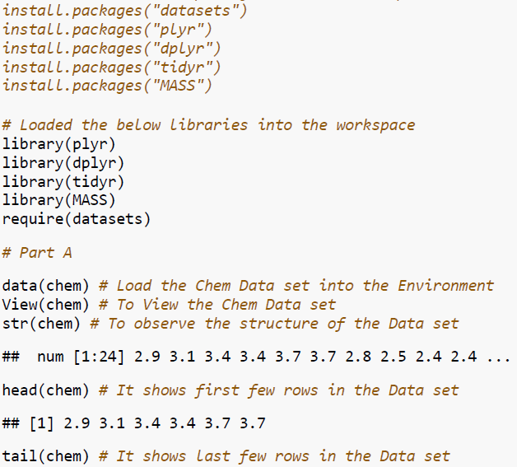

Loaded all the necessary packages into the workspace

**PART B**



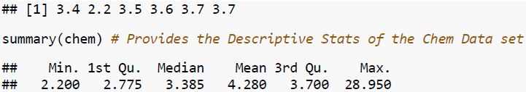

Hence performed a one-sample t-test and here is enough indication to reject the Ho. And, wholemeal flour has > than 1 ppm copper in it.

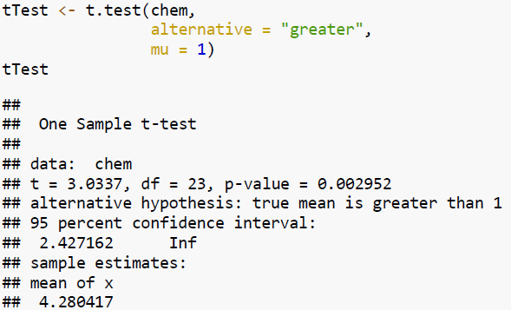

**PART C**

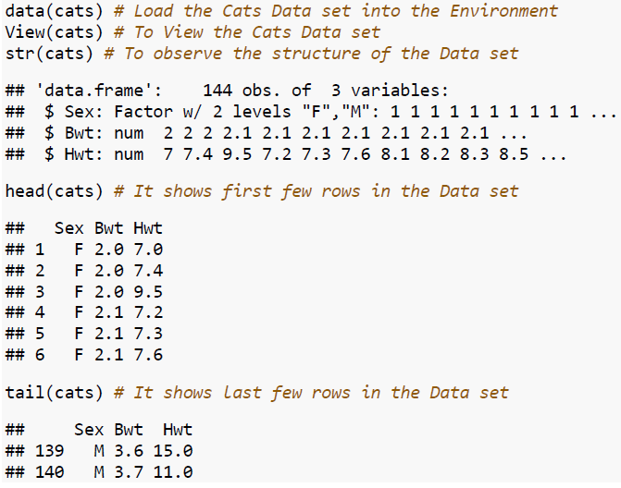

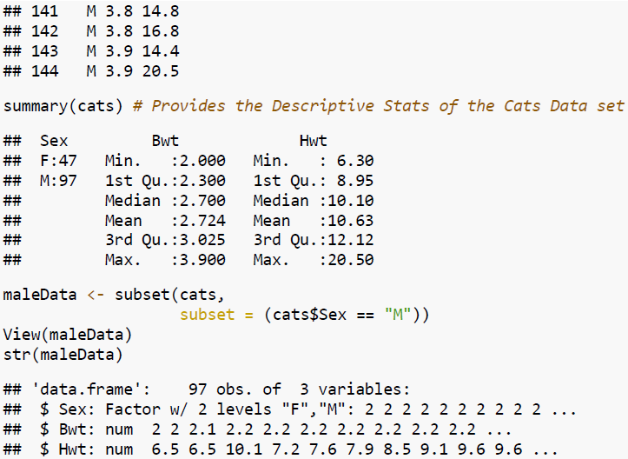

Hence performed a 2-sample t-test and here are enough indications to reject the Ho. And, the male and female cats have the equal bodyweights

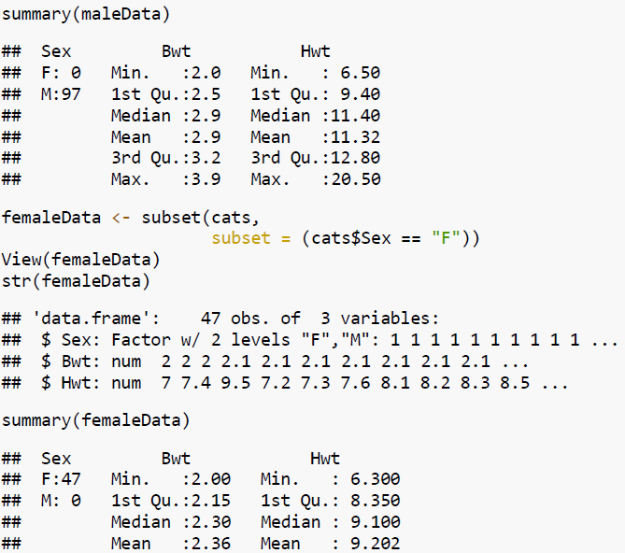

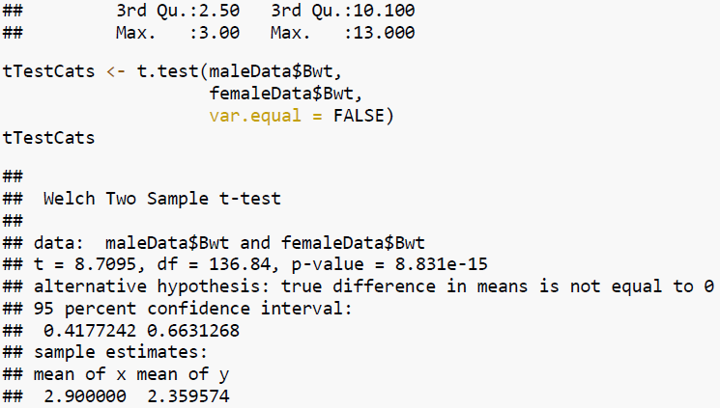

**PART D**

Hence performed paired t-test and here is enough indication to reject the Ho. And, material A is better than material B

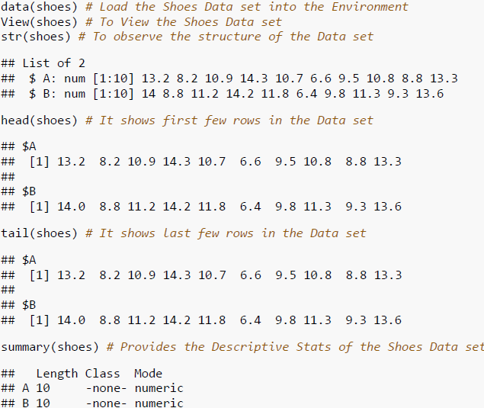

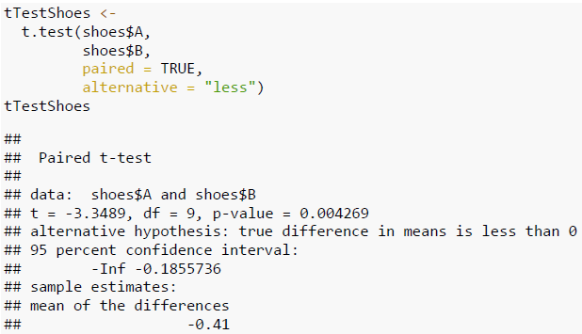

**PART E**

Hence performed test of equal or given proportions and here are enough indication to reject the Ho. And, the drug treatment has a significant effect on the presence of the bacteria compared with the placebo. Also, the p-value is < the alpha value of 0.05.

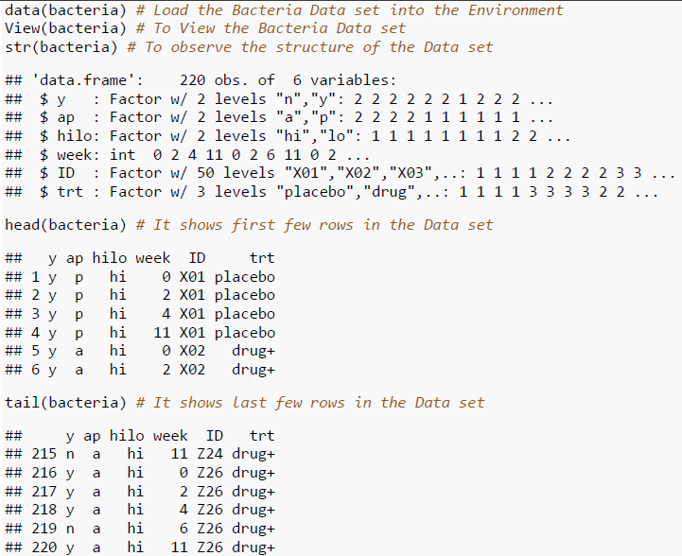

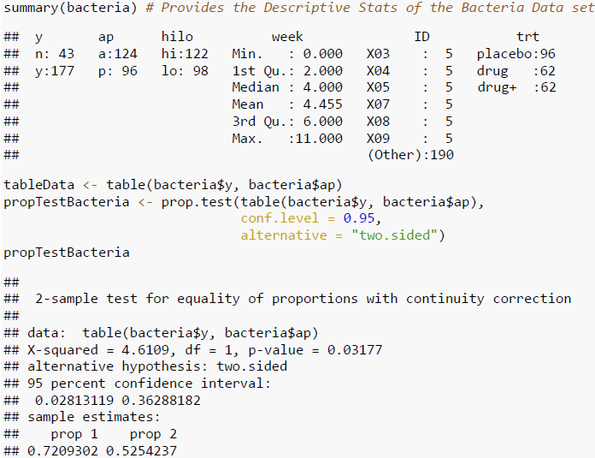

**PART F**

Hence performed an f-test and here are enough indication to reject the hypothesis where variances of x and y are equal. As, the p-value = 0.0001157, which is much less than 0.05

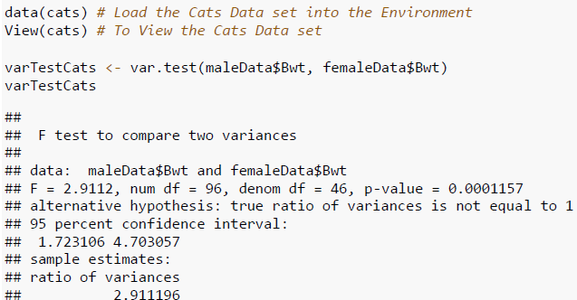

**Conclusion**

To perform multiple analytical operations, we use R on a wider range of data like various datasets. R is a very powerful tool to perform analysis which is mainly built by researchers, statisticians, and developers. In the beginning, we did Descriptive Statistics Analysis, Exploratory Data Analysis, and continued with the Hypothesis Testing to get understandings from the provided data. We performed the 1-sample test, 2-sample t-test, paired t-test, a test of equal or given proportions, and f-test for several datasets to solve given business problems. Ho and Ha are essential in performing the Hypothesis testing for the datasets to make and take data-driven business decisions.

**References**

[1] Phil Spector, using t-tests in R Originally for Statistics 133 was retrieved from <https://statistics.berkeley.edu/computing/r-t-tests>

[2] Test of Equal Or Given Proportions was retrieved from <https://www.rdocumentation.org/packages/stats/versions/3.4.1/topics/prop.test>

[3] F-Test: Compare Two Variances in R was retrieved from <http://www.sthda.com/english/wiki/f-test-compare-two-variances-in-r#compute-f-test-in-r>

[4] Brian Ripley, Bill Venables, Douglas M. Bates, Kurt Hornik, Albrecht Gebhardt, David Firth (Sept 9, 2020), Package “MASS” was retrieved from <https://cran.r-project.org/web/packages/MASS/MASS.pdf>